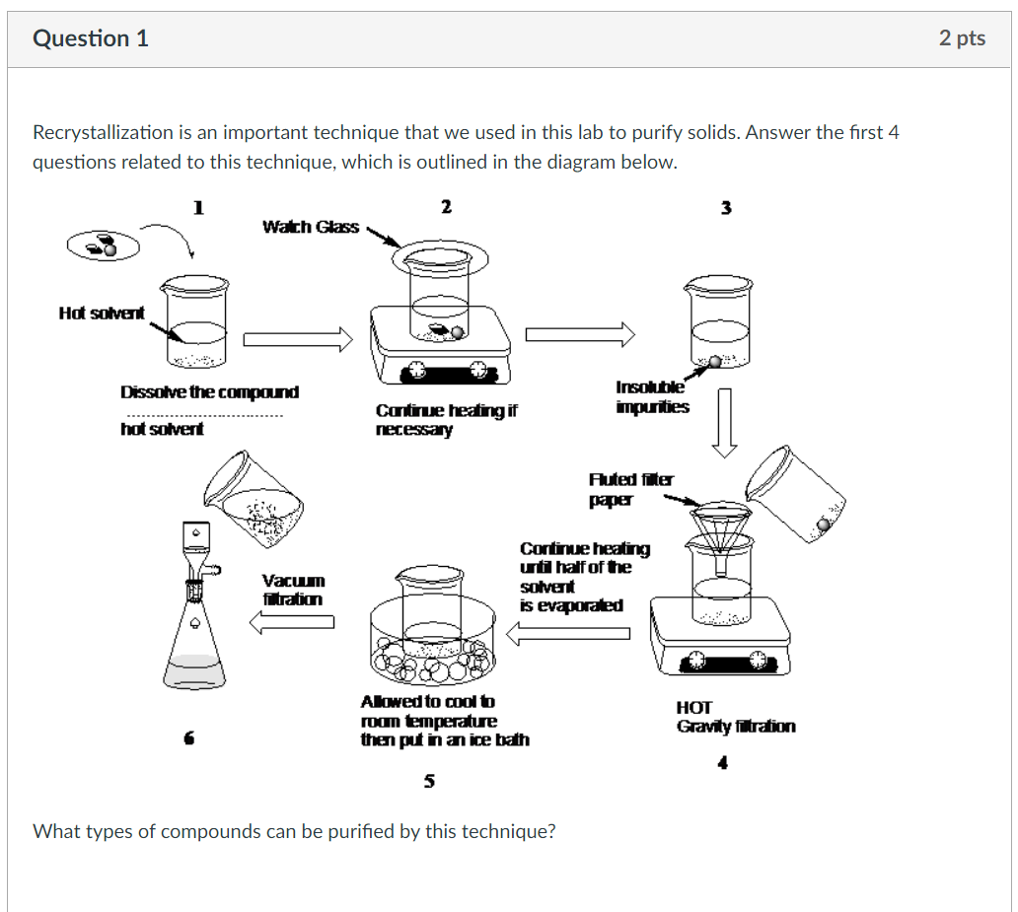
Any compound which is a solid and does not decompose in a given temperature range, has the biggest proportion in a given mixture, and has a solubility curve that increases steeply with increasing temperature in a given solvent.
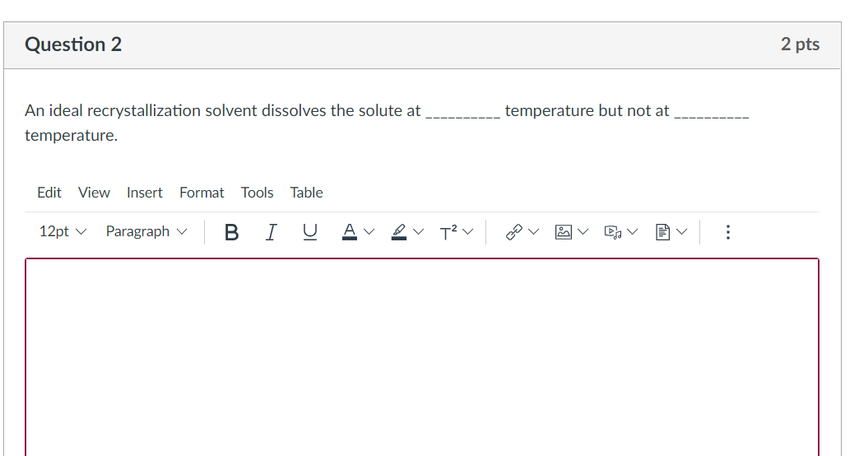
At HIGH temperature but not at LOW temperature
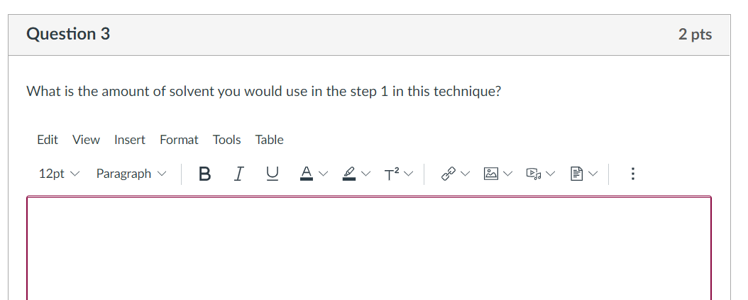
Just small amount of solvent such that it does not dissolve all of the solid to be purified yet.
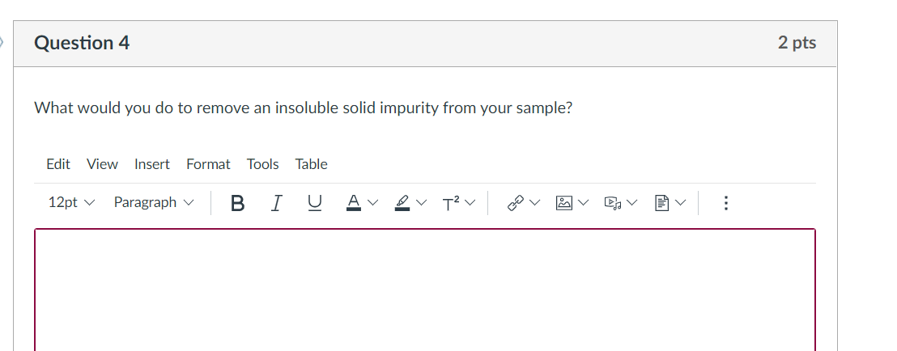
Perform hot gravity filtration just like depicted in the fourth step in the figure.

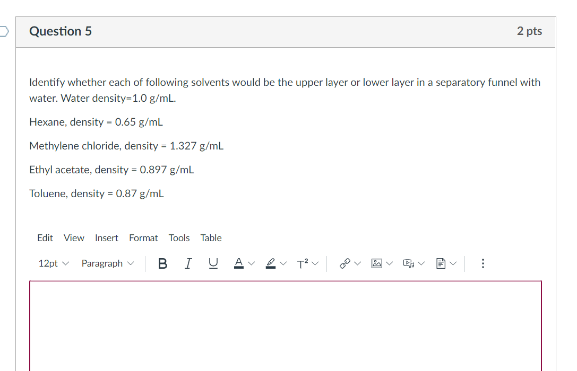
Lower layer (higher density): methylene chloride
Upper layer (lower density): hexane, ethyl acetate, and toluene
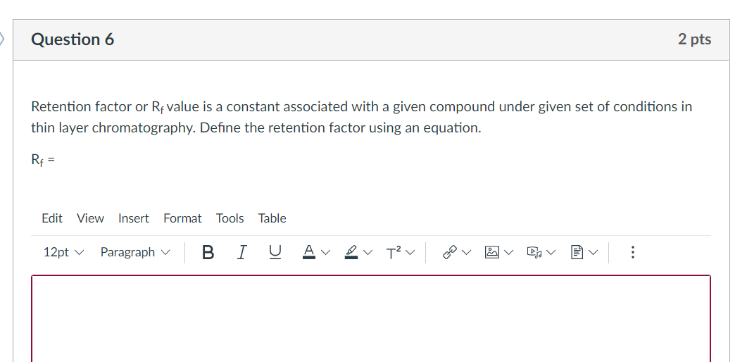
$$R_{f}=\frac{Distance traveled by the solute}{Distance traveled by the mobile phase}$$
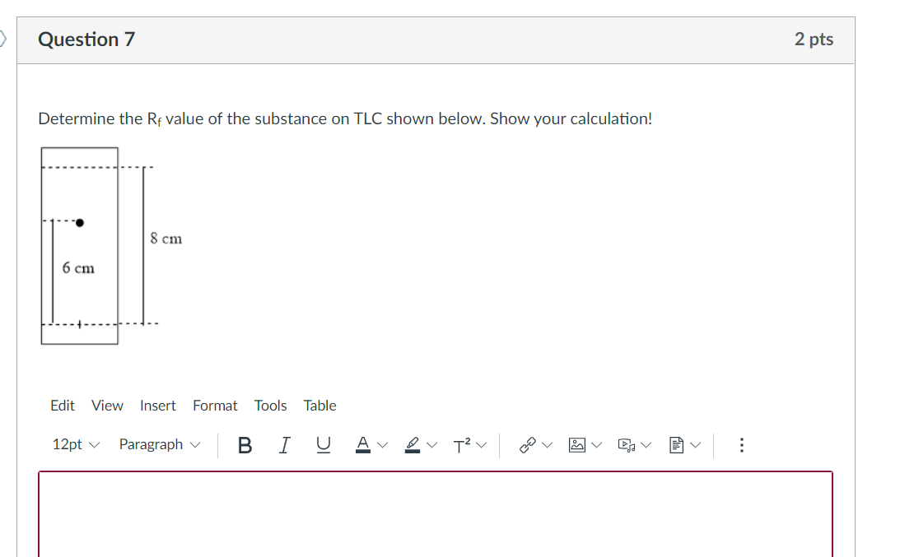
$$R_{f}=\frac{6 cm}{8 cm}=\boxed{0.75}$$
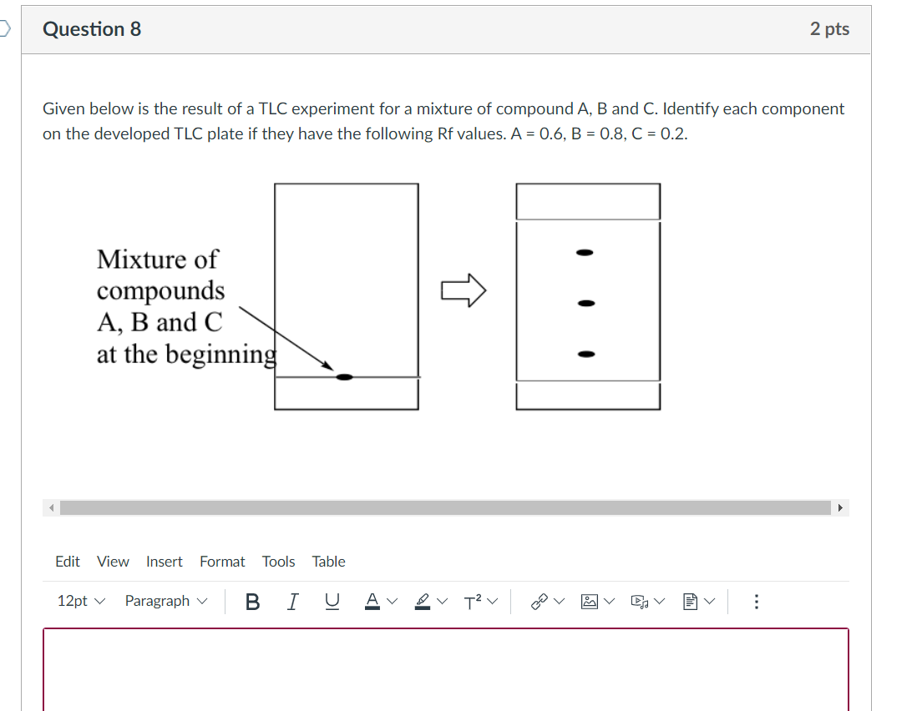
B
A
C
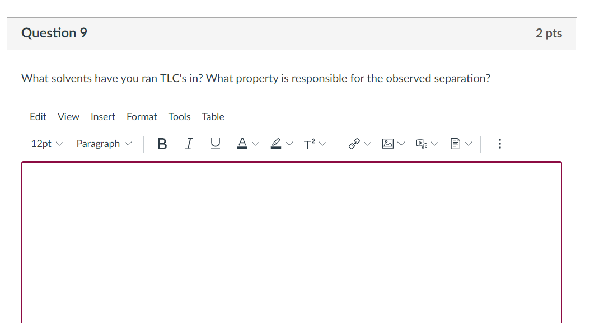
What solvents: Impossible for me to answer – let the students answer themselves 😊
Property: polarity of the solute (ability to interact with the mobile phase or stationary phase)
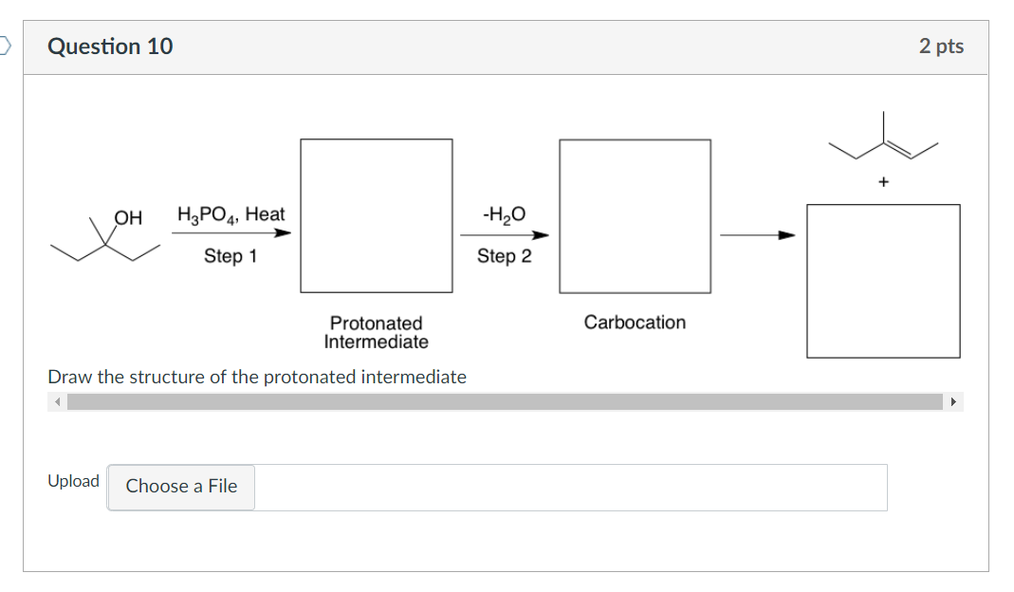
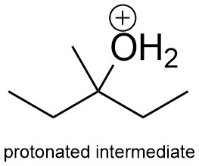
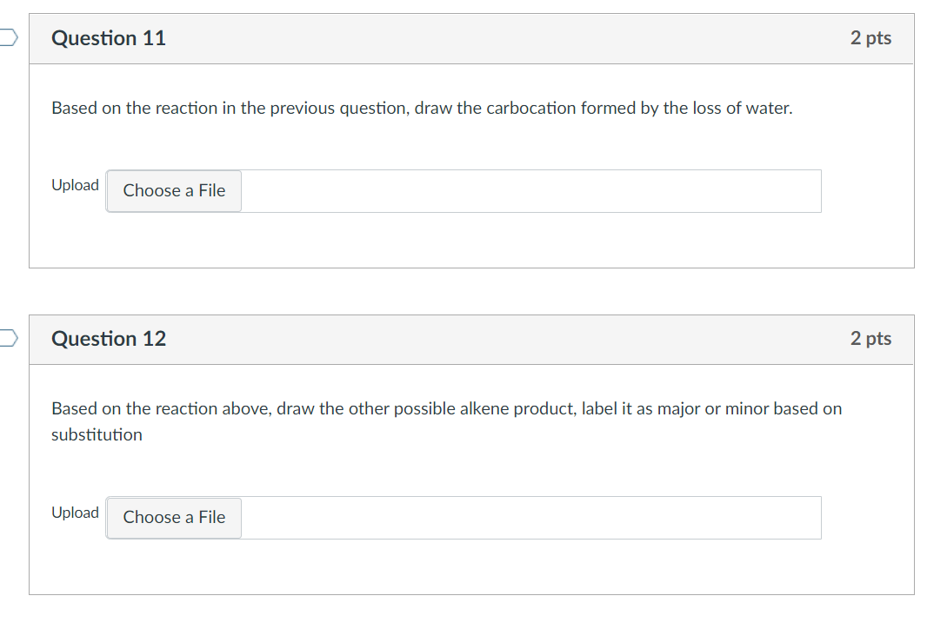
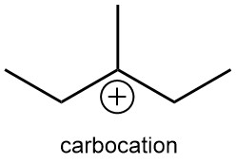
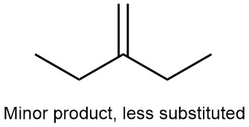
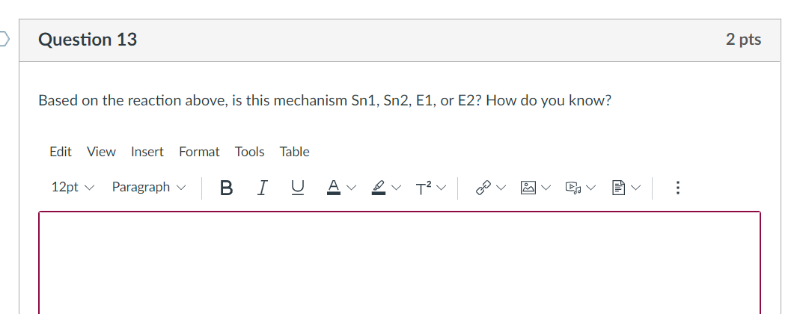
E1, as the slowest step in the reaction involves the formation of carbocation and it gives an elimination product.
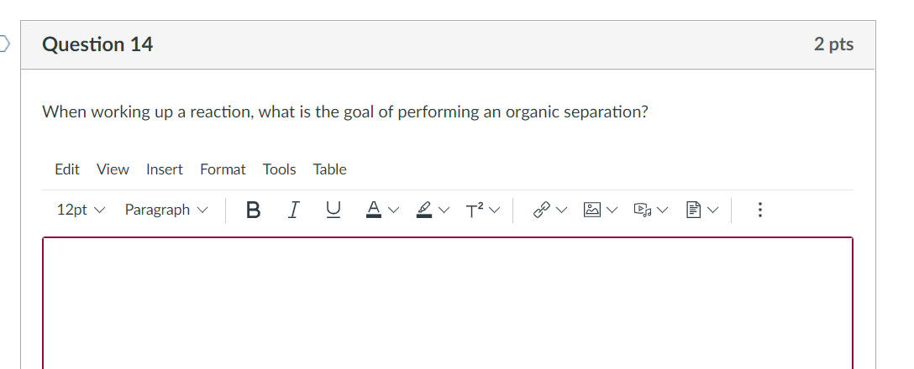
To isolate the desired compound from an impure mixture of compounds.
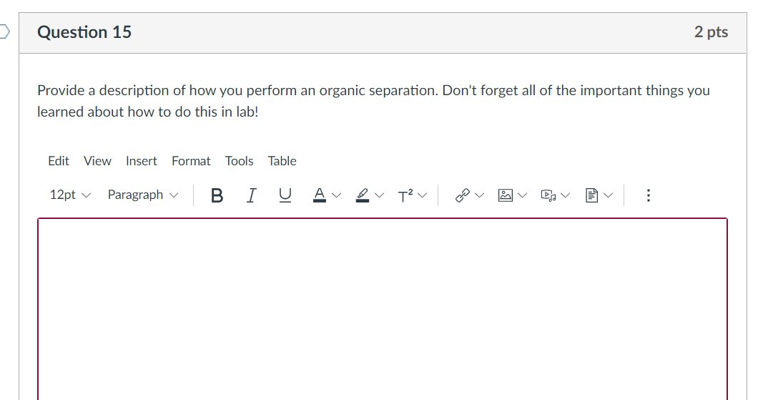
The solid mixture to be separated is dissolved in an organic solvent. The solution is transferred to a separatory funnel, then an extracting solvent (aqueous layer) is added to the funnel. The funnel is then capped on, and a first-time venting is performed to avoid pressure build-up. Then, the funnel is shaken to allow the mixing of the two layers together with periodical venting, which in turns cause the undesired compound to be extracted to the aqueous layer. The aqueous layer is drained and subsequent extraction steps could be performed, if necessary.
If a slightly polar solvent is used as the organic layer, subsequent washing steps with saturated brine solution might be required to remove a large amount of water in the organic layer. The resulting solution is transferred to a flask, then a drying step using a drying agent (MgSO₄ or Na₂SO₄ or CaCl₂) could be performed to remove the remaining moisture. Then, the solvent could be removed in vacuo to obtain the desired solid compound.
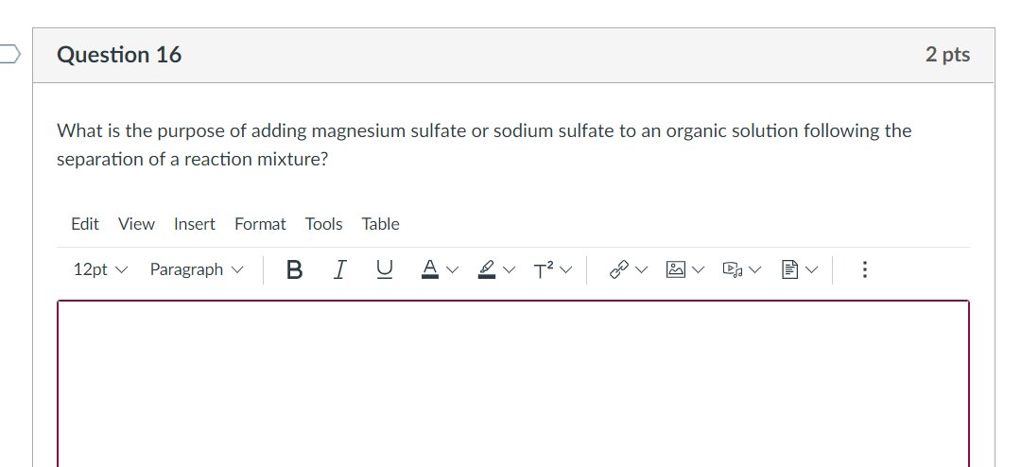
Magnesium sulfate and sodium sulfate are drying agent that absorb moisture of water (H₂O) impurities that is present after an organic separation is performed.
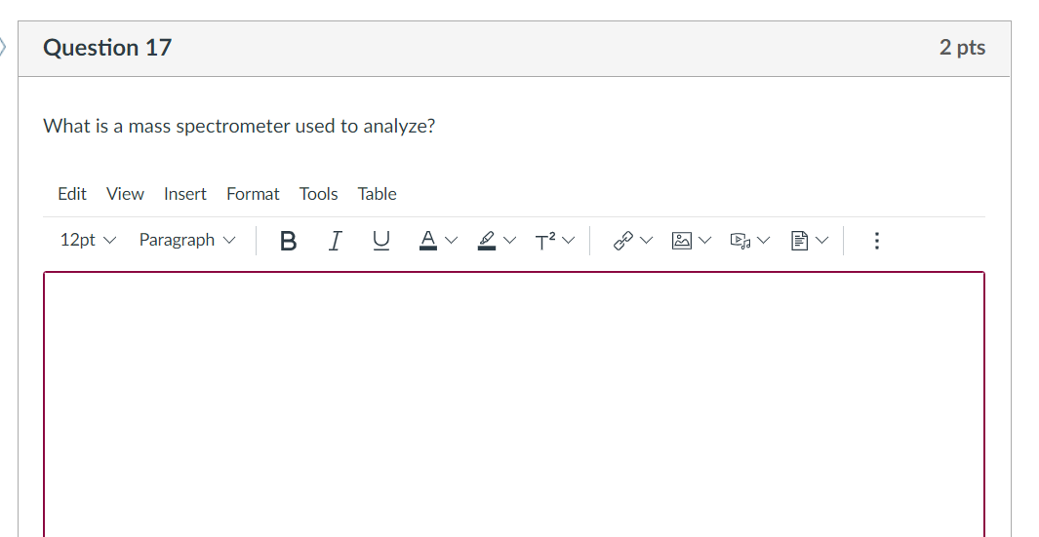
It is used to analyze the molecular mass of a compound and its molecular fragment species when the compound is subjected to ionization.
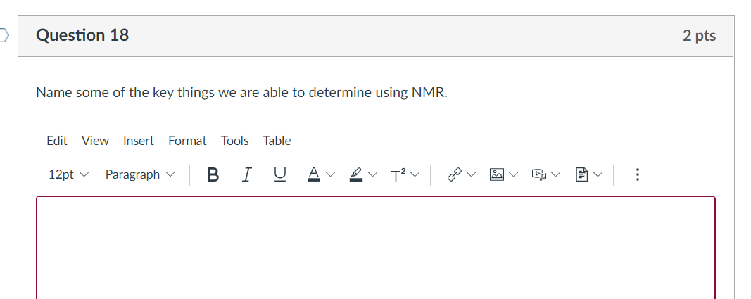

Chemical shift: gives information about the electron density surrounding an atom’s nucleus, possibly giving information about the functional groups present in a compound.
Multiplicities: gives information about the atoms located close to a nucleus that gives rise to the signal.
Integration: gives information about the number of nucleus giving the same NMR signal.
Coupling constant: complements multiplicity, possibly giving information about the stereochemistry of the compound.
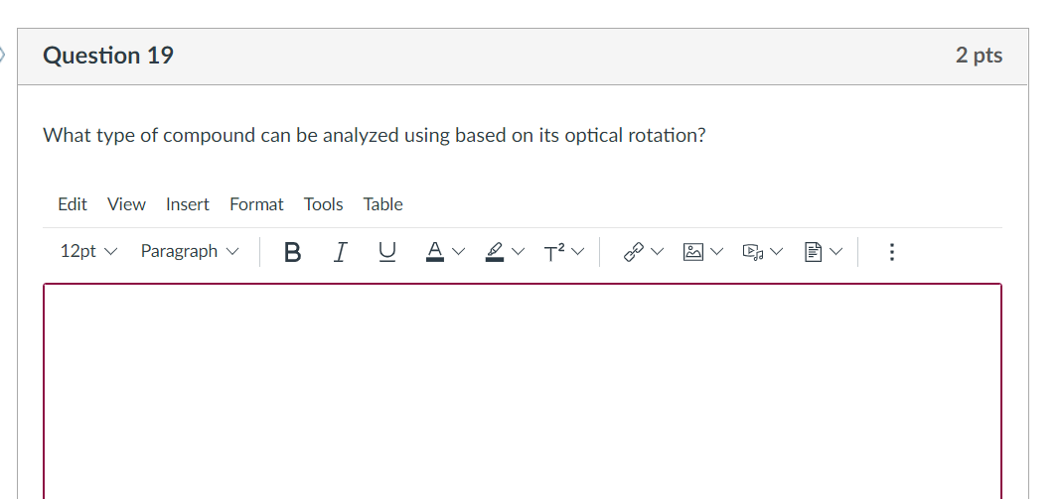
Compounds that can rotate the plane of polarized light in polarimeter (chiral compounds).
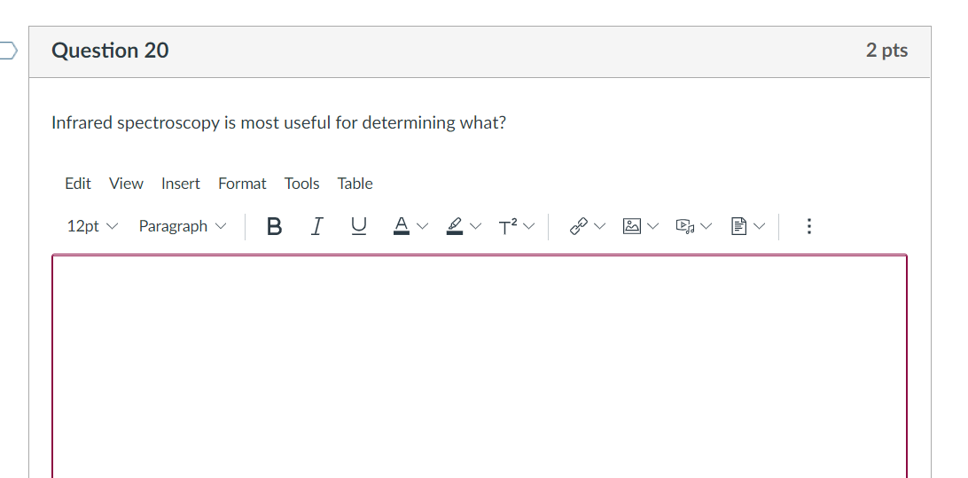
The functional groups present in an organic compound.

